# *Lab 8 – Sequence & Communication Diagrams Introduction*

Date assigned: Wednesday, March 8, 2017

Date due: **Wednesday, March 8, 2017, 3:00 PM**

**Learning Objectives**

Upon successful completion of this lab exercise, the student will be able to:

* Practice with Sequence Diagrams
* Practice with LucidCharts

Lab Set Up

1. Rename this file: YourUserName_E21_L08_SequenceComm_Diagrams.docx

To do:

1. (This lab assumes you know how a browser works. If you do not, please see your professor for guidance.) Create a sequence diagram for the following process.

A user is browsing the web. User requests (<http://www.cegep-heritage.qc.ca/>).

Model the page load and update using the entities:

* 1. Browser
  2. Host OS networking services (that the browser is running on)
  3. DNS (to resolve the IP address of the URL for the first fetch, assume it is cached by the OS after that).
  4. Web server (for cegep-heritage.qc.ca)

The web page has 2 images ( heritage_logo_header.jpg, heritage_background.jpg) and javascript which request an asynchronous (AJAX) JSON file news_of_the_day.JSON which is formatted and displayed once loaded.

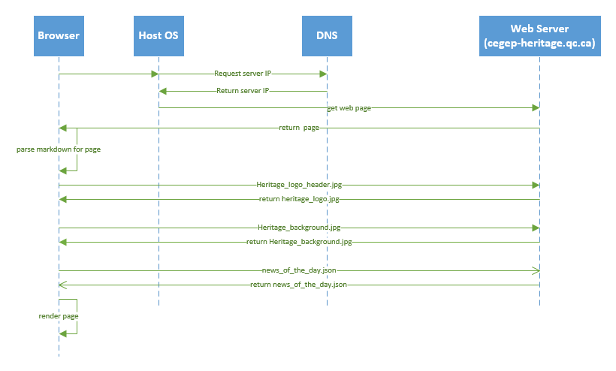

1. Create a Communications diagram for the scenario (above).

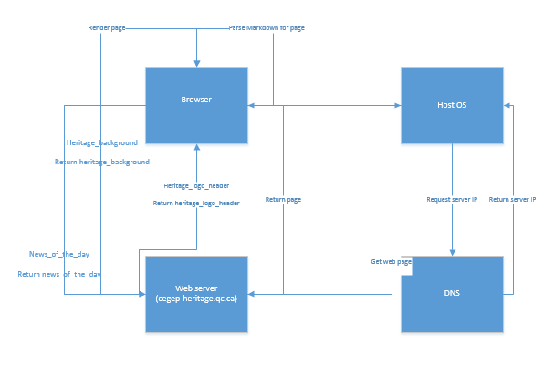

To Submit

Paste your diagrams into this file and submit to Moodle.